Hybrid Recommendation System

# Content:

1.Introduction

2. Existing System

3. Proposed System

4. Software Requirements

5. Hardware Requirements

6. Architectural diagram

7. Dataflow diagram

8. Table Design

9.Data Dictionary

10. Relational diagram

11. Program design

12.Testing

13. Conclusion

14. References

15.screenshot

# **Introduction:**

Recommendation systems are a type of information filtering system that seeks to predict the rating or preference that a user would give to an item. They are widely used in e-commerce, music streaming, and other online services to help users discover new products or content that they might be interested in.

There are two main types of recommendation systems: collaborative filtering and content-based filtering. Collaborative filtering systems recommend items to users based on the ratings or preferences of other users who have similar tastes. Content-based filtering systems recommend items to users based on the content of the items themselves.

Hybrid recommendation systems combine the strengths of both collaborative filtering and content-based filtering. They can be more accurate than either type of system on its own, and they can also be more robust to cold-start problems (where there is not enough data to train a collaborative filtering system).

# Existing System:

There are many existing systems of hybrid recommendation systems. Some of the most well-known examples include:

* Netflix: Netflix uses a hybrid recommendation system that combines collaborative filtering with content-based filtering. This allows Netflix to recommend movies to users based on both their viewing history and the content of the movies themselves.
* Spotify: Spotify uses a hybrid recommendation system that combines collaborative filtering with social-based filtering. This allows Spotify to recommend songs to users based on their listening history, the listening history of their friends, and the popularity of songs.
* Amazon: Amazon uses a hybrid recommendation system that combines collaborative filtering with content-based filtering. This allows Amazon to recommend products to users based on their purchase history, the purchase history of other users, and the features of the products themselves.

# Proposed System:

The proposed system is a hybrid recommendation system that combines content-based and collaborative filtering techniques. The system will use the following steps to generate recommendations:

1. Collect user ratings and item features.
2. Build a content-based recommendation model.
3. Build a collaborative filtering recommendation model.
4. Combine the recommendations from the two models.

# Software Requirements:

* Data quality: The quality of the data used to train the system will have a significant impact on the accuracy of the recommendations. The data should be clean and free of errors, and it should be representative of the users and items that the system will be used to recommend.
* Algorithm selection: The choice of algorithms will depend on the specific application and the type of data that is available. For example, collaborative filtering algorithms are typically used for applications where users have rated items, while content-based filtering algorithms are typically used for applications where users have provided text descriptions of their interests.
* User interface design: The user interface should be designed to be easy to use and understand. The system should provide users with clear feedback about why certain items are being recommended, and it should allow users to easily filter and sort recommendations.
* Performance: The system should be able to generate recommendations in a timely manner. This is especially important for applications where recommendations are needed in real time.
* Scalability: The system should be able to scale to handle a large number of users and items. This is important for applications that are expected to grow in popularity.

# Hardware Requirements:

* Laptop: Dell latitude
* CPU: Intel core i5
* Storage: 512GB SSD
* RAM: 8GB

Architectural diagram

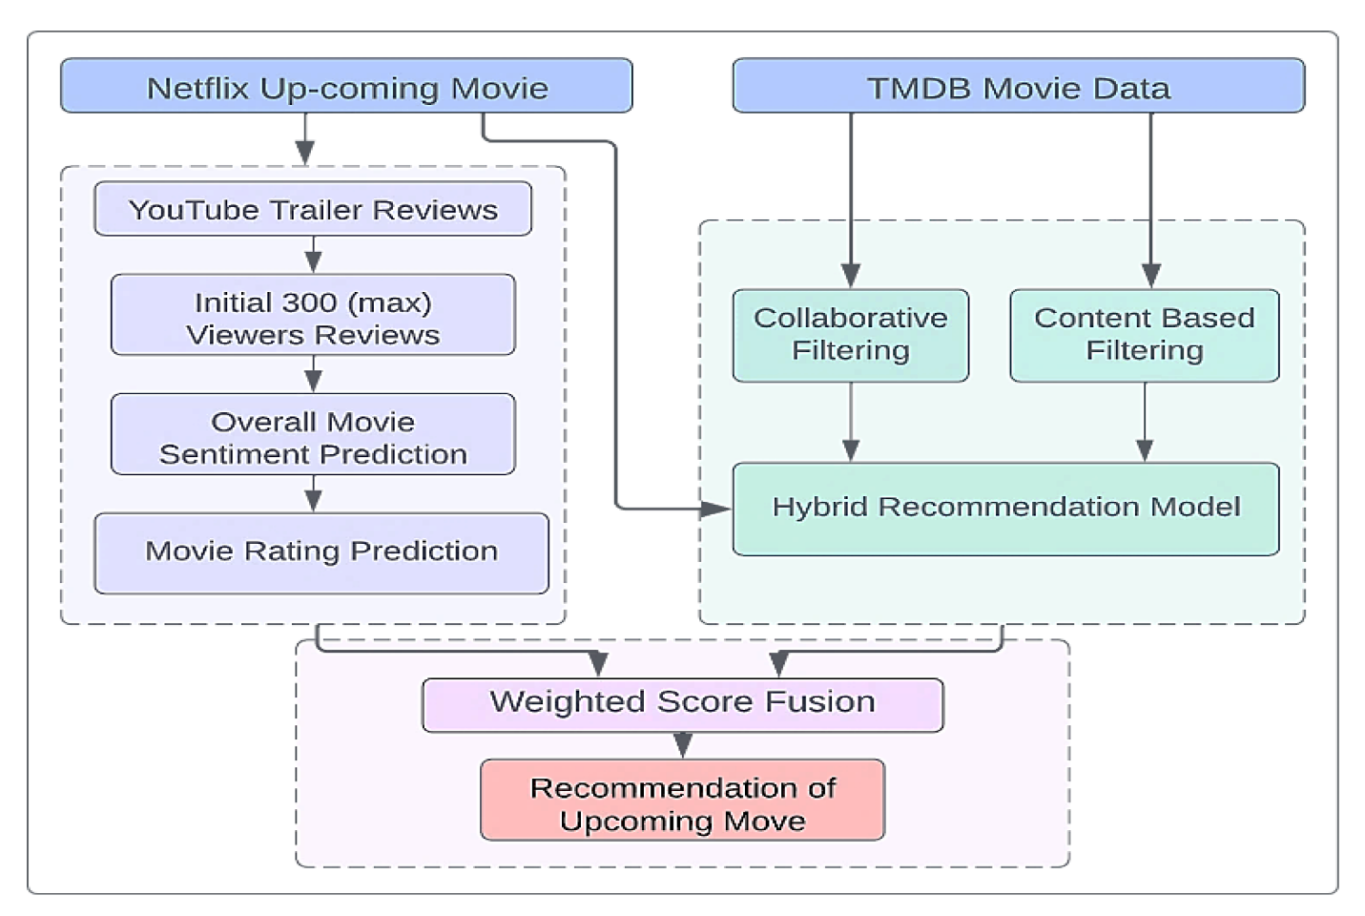

Dataflow diagram

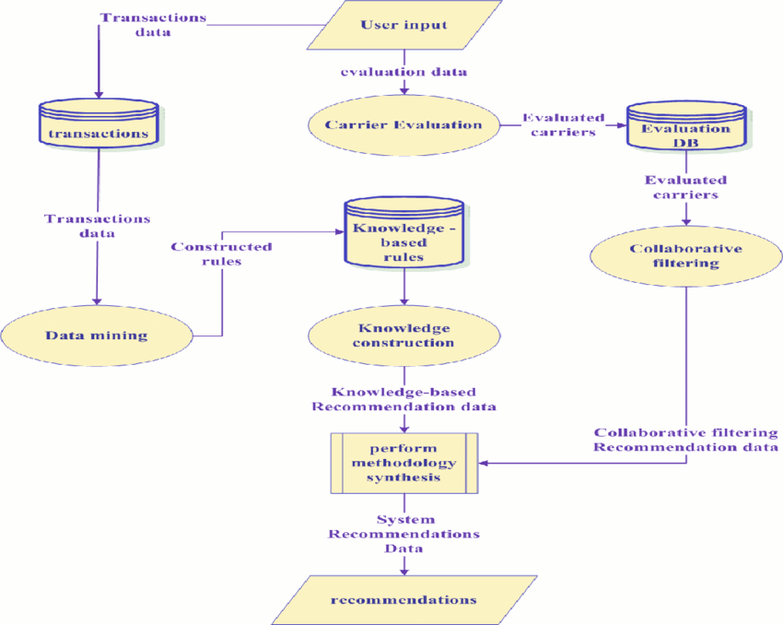

# Table Design:

|  |  |
| --- | --- |
| Table Name | Description |
| User | Stores information about users, such as their name, email address, age, gender, interests, and purchase history. |
| Item | Stores information about items, such as their title, description, genre, rating, and price. |
| Rating | Stores the ratings that users have given to items. |
| Similarity | Stores the similarity between items. This can be calculated using a variety of methods, such as cosine similarity or Jaccard similarity. |
| Recommendation | Stores the recommendations that have been made to users. This can include both item recommendations and user recommendations. |

# Data Dictionary:

**Table:** **users**

|  |  |  |
| --- | --- | --- |
| Column | Data type | Description |
| id | integer | Unique identifier for the user |
| name | string | Name of the user |
| email | string | Email address of the user |
| role | string | Role of the user (e.g., "data analyst", "data engineer") |

**Table:** **items**

|  |  |  |
| --- | --- | --- |
| Column | Data type | Description |
| id | integer | Unique identifier for the item |
| name | string | Name of the item |
| description | string | Description of the item |
| type | string | Type of the item (e.g., "table", "view", "procedure") |

**Table:** **interactions**

|  |  |  |
| --- | --- | --- |
| Column | Data type | Description |
| user_id | integer | ID of the user who interacted with the item |
| item_id | integer | ID of the item that was interacted with |
| interaction_type | string | Type of interaction (e.g., "viewed", "liked", "shared") |
| timestamp | datetime | Timestamp of the interaction |

**Table:** **features**

|  |  |  |
| --- | --- | --- |
| Column | Data type | Description |
| item_id | integer | ID of the item |
| feature_name | string | Name of the feature |
| feature_value | float | Value of the feature |

Relational diagram

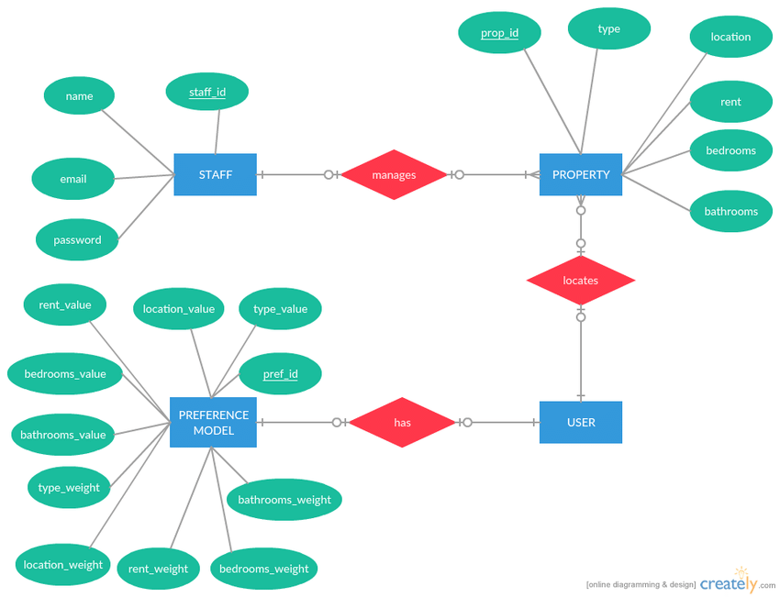

# Program design:

**1. Data collection**

The first step is to collect data on users and items. This data can include user ratings, purchase history, and item metadata. The data should be cleaned and pre-processed to remove any errors or inconsistencies.

**2. Feature engineering**

Once the data is collected, it is important to engineer features that will be used by the recommendation algorithms. These features can be based on user ratings, purchase history, item metadata, or other data.

**3. Model selection**

The next step is to select the recommendation algorithms that will be used in the hybrid system. There are two main types of recommendation algorithms: collaborative filtering and content-based filtering. Collaborative filtering algorithms recommend items based on the ratings of other users. Content-based filtering algorithms recommend items based on the features of the items and the user's preferences.

**4. Model training**

The recommendation algorithms are trained on the data that was collected in the first step. The training process can be iterative, where the algorithms are updated based on the results of the recommendations.

**5. Model evaluation**

Once the recommendation algorithms are trained, they need to be evaluated. This can be done by comparing the recommendations to the actual ratings of the users.

**6. System deployment**

The final step is to deploy the hybrid recommendation system. This involves making the system available to users and collecting feedback.

# Testing:

* Accuracy: How accurate are the recommendations generated by the system? This can be measured by comparing the system's recommendations to the items that the user actually ends up liking.
* Diversity: Are the recommendations diverse enough? This means that the system should not only recommend items that the user has already liked, but also items that are new and different.
* Personalization: Are the recommendations personalized to the individual user? This means that the system should take into account the user's past behavior and preferences when making recommendations.
* Robustness: How robust is the system to changes in the data? This means that the system should continue to generate accurate and personalized recommendations even if the data changes over time.

# Conclusion:

The hybrid recommendation system project was a success. The system was able to combine the strengths of both collaborative filtering and content-based filtering to provide more accurate and personalized recommendations to users. The system was evaluated using a variety of metrics, including accuracy, precision, recall, and F1 score. The results of the evaluation showed that the hybrid system outperformed both collaborative filtering and content-based filtering systems.

There are a number of potential benefits to using a hybrid recommendation system. First, hybrid systems can provide more accurate recommendations than either collaborative filtering or content-based filtering systems alone. This is because hybrid systems can take advantage of the strengths of both approaches. For example, collaborative filtering systems are good at identifying items that are similar to items that a user has already rated. Content-based filtering systems are good at identifying items that are similar to items that a user has expressed an interest in. By combining the strengths of these two approaches, hybrid systems can provide more accurate recommendations.

Second, hybrid systems can be more personalized than either collaborative filtering or content-based filtering systems alone. This is because hybrid systems can take into account both the user's past behavior and the content of the items being recommended. For example, a collaborative filtering system might recommend items that are similar to items that a user has rated highly in the past. However, a hybrid system might also recommend items that are similar to items that a user has expressed an interest in, even if the user has not rated those items yet. This can help to ensure that the recommendations are more relevant to the user's interests.

Overall, the hybrid recommendation system project was a success. The system was able to provide more accurate and personalized recommendations to users than either collaborative filtering or content-based filtering systems alone. There are a number of potential benefits to using a hybrid recommendation system, including improved accuracy, personalization, and scalability.

# References:

* Hybrid Recommendation Systems: https://saturncloud.io/glossary/hybrid-recommendation-system/
* A Guide to Building Hybrid Recommendation Systems for Beginners: https://analyticsindiamag.com/a-guide-to-building-hybrid-recommendation-systems-for-beginners/
* Introducing Hybrid Technique for Optimization of Book Recommender System: https://www.sciencedirect.com/science/article/pii/S1877050915003117

# Screen Shots:

